**ACE-LEAVE-PORTAL**

**REAL TIME PROJECT**

**Bachelor of Technology (B.Tech-II year / II Semester)**

**In**

**COMPUTER SCIENCE AND ENGINEERING**

**By**

**B. PRAMOD 22AG1A0507**

**P.G.KEERTHI 22AG1A0539**

**Y.OJASWINI 22AG1A0561**

**Under the Esteemed Guidance of**

**Dr. V. Ravi Kumar**

Assistant Professor





**Department of Computer Science and Engineering**

***ACE ENGINEERING COLLEGE***

**An Autonomous Institution**

(NBA ACCREDITED B.TECH COURSES: EEE, ECE, MECH, CIVIL & CSE, ACCORDED NAAC ‘A’ GRADE)

**(Affiliated to Jawaharlal Nehru Technological University, Hyderabad, Telangana)**

Ankushapur(V),Ghatkesar(M), Medchal – MalkajgiriDist - 501 301

JULY 2024

**ACE**

**Engineering College**

**An Autonomous Institution**

**Web site:** [**www.aceec.ac.in E-**](http://www.aceec.ac.in/)**mail:** [**info@aceec.ac.in**](mailto:info@aceec.ac.in)

**DEPARTMENT OF COMPUTER SCIENCE AND ENGINEERING**

**CERTIFICATE**

This is to certify that the Real Time Project work entitled **“ACE LEAVE PORTAL”** is being submitted by **B.Pramod (22AG1A0507), P.G.Keerthi (22AG1A0539), Y.Ojaswini (22AG1A0561)** in partial fulfillment of Real Time Project work during the academic year 2023-24 is a record of bonafide work carried out by them under our guidance and supervision.

**Internal Guide**

**Head of the Department**

**Dr.V.Ravi Kumar**

**Associate Professor**

**Dept. of CSE**

**Dr.M.V.VIJAYASARDI**

**Professor and Head**

**Dept. of CSE**

**Project Coordinator**

**ACKNOWLEDGEMENT**

I would like to express our gratitude to all the people behind the screen who have helped me, transform an idea into a real time application.

I would like to express my heart-felt gratitude to our parents without whom I would not have been privileged to achieve and fulfill my dreams.

A special thanks to our Secretary, **Prof. Y. V. GOPALA KRISHNA MURTHY,** for having founded such an esteemed institution. I am also grateful to our beloved principal, **Dr.**

**B. L. RAJU** for permitting us to carry out this project.

I profoundly thank **Dr. M. V. VIJAYA SARADHI**, Head of the Department of Computer Science and Engineering, who has been an excellent guide and also a great source of inspiration to my work.

I extremely thank **Dr.V.Ravi Kumar** Associate Professor, Project coordinator who helped us in all the way in fulfilling of all aspects in completion of our Mini-Project.

I am very thankful to my internal guide **Dr.V.Ravi Kumar,** Associate Professor, of the Department of Computer Science and Engineering who has been an excellent and also given continuous support for the Completion of my project work.

The satisfaction and euphoria that accompany the successful completion of the task would be great, but incomplete without the mention of the people who made it possible, whose constant guidance and encouragement crown all the efforts with success. In this context, We would like to thank all the other staff members, both teaching and non-teaching, who have extended their timely help and eased our task.

**B. PRAMOD (22AG1A0507)**

**P.G.KEERTHI (22AG1A0539)**

**Y.OJASWINI (22AG1A0561)**

**ABSTRACT**

The most common problem faced by students these days is related to Attendance. They get short of attendance due to several factors beyond their control as in the case of an emergency, where they might not be able to send their leave application. There are times when due to lack of coordination with the concerned authorities, they miss the attendance of several important in-campus and off-campus activities such as events, workshops, seminars etc. In some cases, they do not even get the information about the upcoming events which would be beneficial to them. The proposed system automates the existing system. It decreases the paper work and makes the record maintenance process easy by replacing all the traditional methods by computerized techniques. We understand that this project cannot be accomplished with divided thinking. Hence, our technique involves getting into groups and coming up with ideas, known as brainstorming, and this a tried and true method. This technique has many variations. Keeping these problems in our mind and brainstorming over all the possible solutions, we generated an idea of creating an application which would solve all above stated problems. Through a vast discussion, we came up with the proposal. The idea breaks away from traditional thought and creates a different perspective. Our application mainly focuses on the fair distribution of attendance among students. It provides all the related details of working days, holidays, events & workshops taking place in the college. This project is aimed at developing an online Student leave management system that is of importance to either an organization. The Student Leave Management System (SLMS) is an Internet based application that can be accessed throughout the organization. This system can be used to automate the workflow of leave applications and their approvals. The periodic crediting of leave is also automated. There are features like email notifications, automatic approval of leave, report generators etc in this system. Leave Management application will reduce paper work and maintain records in a more efficient way.

|  |  |
| --- | --- |
| **FEASIBILITY STUDY**  **1.Technical Feasibility:** Evaluate the technical requirements and capabilities needed to develop the system.  **Considerations**: Technology stack (PHP, MySQL), server requirements, software tools.  **2.Financial Feasibility:** Analyze the budget required for development, deployment, and maintenance.  **Considerations:** Cost of hosting, software licenses, developer salaries.  **3.Product Feasibility:** Assess the overall viability of the product in terms of market demand and user needs.  **Considerations:** Similar products in the market, potential user base, benefits over existing solutions. |  |

**LITERATURE SURVEY & PRACTICAL OBSERVATION**

1. **INTRODUCTION**
   1. **Purpose** :

The purpose of the Ace Leave Portal project is to streamline and automate the process of managing student leave requests within an educational institution. The system aims to provide a centralized platform for students to submit leave requests, for faculty to review and approve/deny these requests, and for administrators to track and manage leave data efficiently.

Key objectives and purposes of the project include:

**Efficiency:** To improve the efficiency of handling student leave requests by replacing manual, paper-based processes with a digital system that automates workflows and notifications.

Transparency: To enhance transparency by providing real-time status updates on leave requests to students, faculty, and administrators.

**Accuracy:** To reduce errors and ensure accurate record-keeping of student leave data, including reasons for leave, duration, and approval status.

**Compliance:** To ensure compliance with institutional policies and regulations regarding student attendance and leave policies.

**Data Analysis:** To enable data analysis and reporting on student leave trends, patterns, and statistics for informed decision-making and resource planning.

**User Experience:** To enhance the overall user experience for students, faculty, and administrators by providing a user-friendly interface and intuitive functionalities.

**1.2 Scope**

The scope section defines the boundaries of your project. For your Ace Leave Portal, the scope might include:

**Features:** Specify the functionalities of the system, such as leave request submission, approval workflows, notifications, reporting, etc.

**Integration**: Identify any other systems or platforms the leave management system will integrate with, such as student information systems or HR systems.

**User Roles:** Define the different user roles and their permissions within the system, such as students, teachers, administrators, etc.

**Platforms**: Clarify the platforms on which the system will be accessible, such as web, mobile, or both.

**Exclusions**: Mention any features or functionalities that are explicitly not included in the project.

**1.3. REAL-TIME USAGE & APPLICATIONS**

**Leave Application:** Students can easily apply for leave online.

**Approval Process:** Advisors review and approve leave applications with instant email notifications sent to students.

**Event Registration:** Students can register for workshops and events with automatic attendance tracking.

**Reporting:** Administrators can generate detailed attendance reports.

**Notifications:** Timely alerts are sent to students and faculty about important events and deadlines.

**1.4. TARGET AUDIENCE**

**Students:** Apply for leave online, Register for events and workshops and Track their attendance.

**Faculty and Advisors:** Review and approve student leave applications and Manage and track attendance.

**Administrators:** Generate detailed attendance reports and Oversee attendance policies and event participation.

**Educational Institutions:** Schools, colleges, and universities seeking to improve their leave and attendance processes.

**Parents and Guardians:** Monitor their children's attendance and school activities.

**2. OVERALL DESCRIPTION**

**2.1 User Interfaces & Characteristics**

**Web Interface:** For accessing the system through a web browser..

**User Dashboard:** Providing an overview of leave requests, approvals, and other relevant information.

**Forms**: For submitting leave requests, approving or denying requests, etc.

Notifications: How users will receive notifications about their leave requests or approvals / denials.

**CHARACTERISTICS:**

**Students:**

Familiarity with web-based applications and mobile devices

Varying levels of technical expertise

Need for a user-friendly interface to submit leave requests

**Faculty:**

Experienced in using web-based applications

Require efficient workflows for reviewing and approving/denying leave requests

Need for timely notifications and access to leave request history

**Administrators:**

Proficient in using web-based applications and data management tools

Responsible for managing user accounts, system configurations, and data analysis

Need for comprehensive reporting and analytics capabilities.

**2.2 System Interfaces & Communication Interfaces**

**Student Information System**: The system will fetch student data, such as personal information and academic details, from the existing student information system.

**Email/Notification System:** The system will integrate with an email or notification service to send automated updates and alerts to users regarding leave request status and approvals.

**Calendar Services:** For syncing leave requests with personal calendars.

**User Authentication Systems:** How users will log in to the system.

**3. System Analysis**

**3.1 Existing System & Drawbacks**

The existing student leave management system relies on manual processes where students submit leave requests through traditional methods. This manual approach results in time-consuming administrative tasks, repetitive data entry, and record maintenance. The current system lacks automation, leading to delays in leave verification and approval processes. The manual verification process adds to the administrative workload, making it cumbersome and prone to errors. Overall, the existing system is inefficient, paper-intensive, and requires significant manual intervention for leave management tasks.

**Drawbacks:**

**Time-Consuming:** Manual processes for applying for leave and tracking attendance are slow.

**Error-Prone:** Manual data entry increases the risk of errors in attendance records.

**Lack of Real-Time Updates:** Students and faculty do not receive immediate notifications about leave status or event updates.

**3.2 Proposed System & Overcoming Drawbacks**

The proposed Ace Leave Portal is a web-based application designed to revolutionize the leave application and approval procedures within educational institutions. This system aims to automate and streamline the entire workflow of student leave requests, providing relief from paperwork-intensive legacy systems. Key features of the proposed system include:

**Leave Request Submission:** Students can initiate the leave application process by logging into the system, filling in required details like leave dates and reasons.

Immediate Acknowledgment: Upon submission, students receive immediate acknowledgment of their leave request.

**Approval Workflow:** Leave requests are automatically forwarded to relevant authorities for approval, typically faculty members or clerks.

**Real-time Status Updates:** Students can check the status of their leave requests at any time, with the system providing real-time updates on approval status.

**Overcoming Drawbacks:**

**Time Efficiency:** Automation reduces the time required for leave application processing and attendance tracking.

**Accuracy and Error Reduction:** Automated data entry and validation minimize errors in attendance records and leave processing.

**Real-Time Updates:** Instant notifications ensure stakeholders are informed promptly about leave approvals, event registrations, and updates.

**3.3 Team Size**

B. Pramod

Role: Project Manager / Backend Develope

P.G. Keerthi

Role: Frontend Developer

Y. Ojaswini

Role: Tester / Documentation Specialist

**4.SOFTWARE AND HARDWARE REQUREMENTS**

**Software:**

* The system will be developed using Django or React framework for backend development.
* Frontend will be designed using HTML, CSS, and JavaScript for a responsive user interface.
* Database management will be handled using PostgreSQL for data storage.

**Hardware:**

* Computer with i3, 4GB RAM (or) Mobile phone.
* Frontend will be designed using ReactJS for a responsive user interface.

**5. Architecture Diagram / Flow Diagram / Hierarchical Chart /**

**Pie Chart**

**Architecture Diagram:**

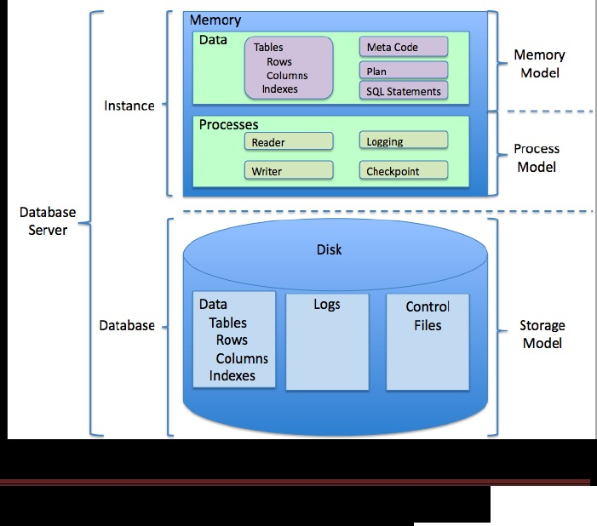

**FLOW DIAGRAMS:**

**Flowchart:**

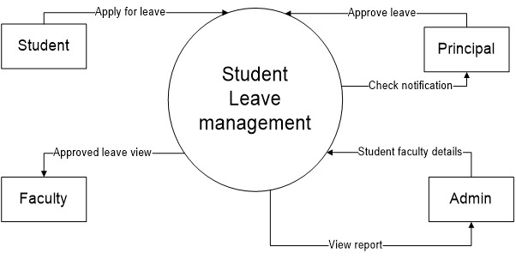

**Student chart:**

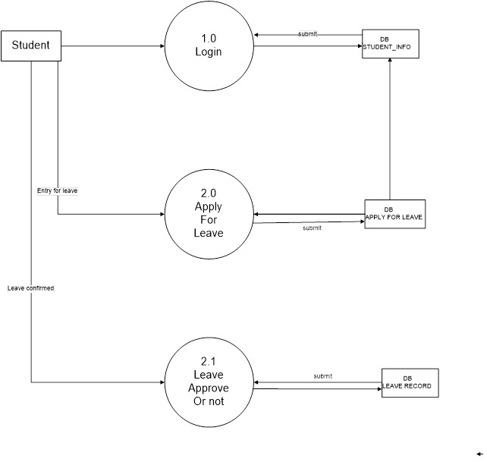

**Admin chart:**

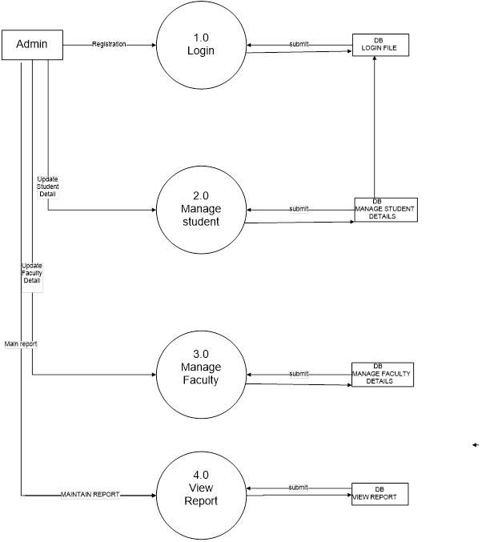

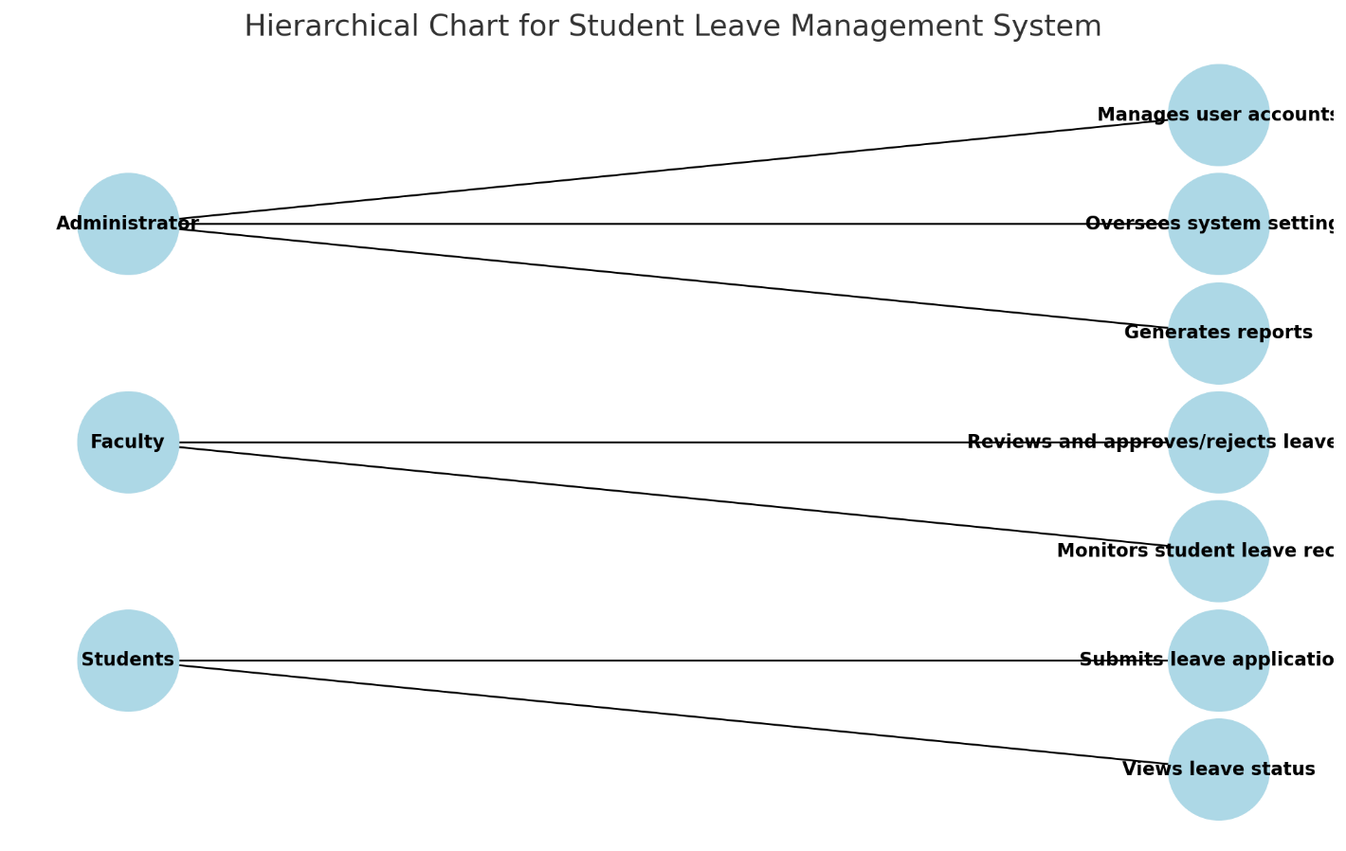**Hierarchical char**

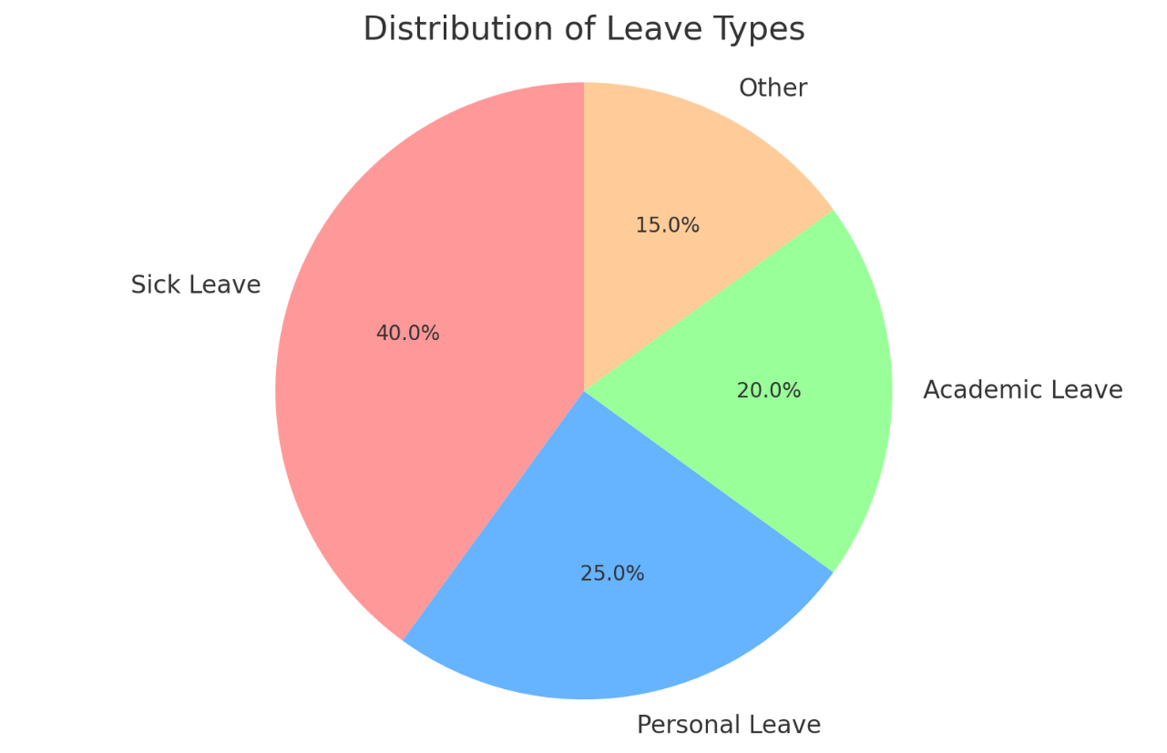**Pie Chart**

**6.SOFTWARE DESIGN**

**1.Use Case Diagram**



1. **Sequence Diagram**

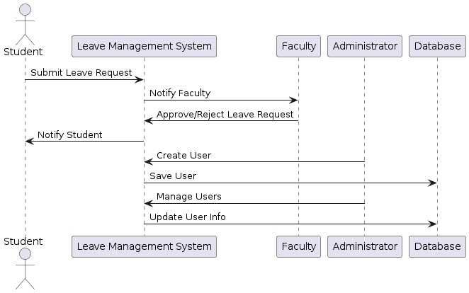

1. **Class**

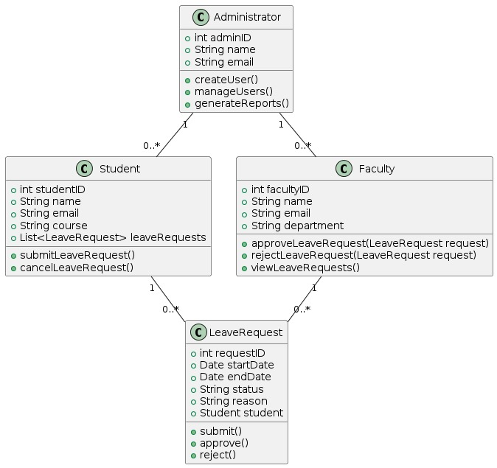

1. **Activity Diagram**

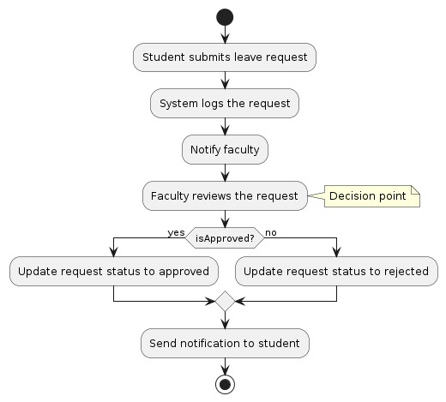

1. **State Diagram**

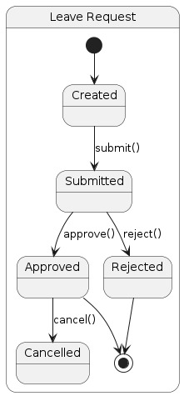

1. **Component Diagram**

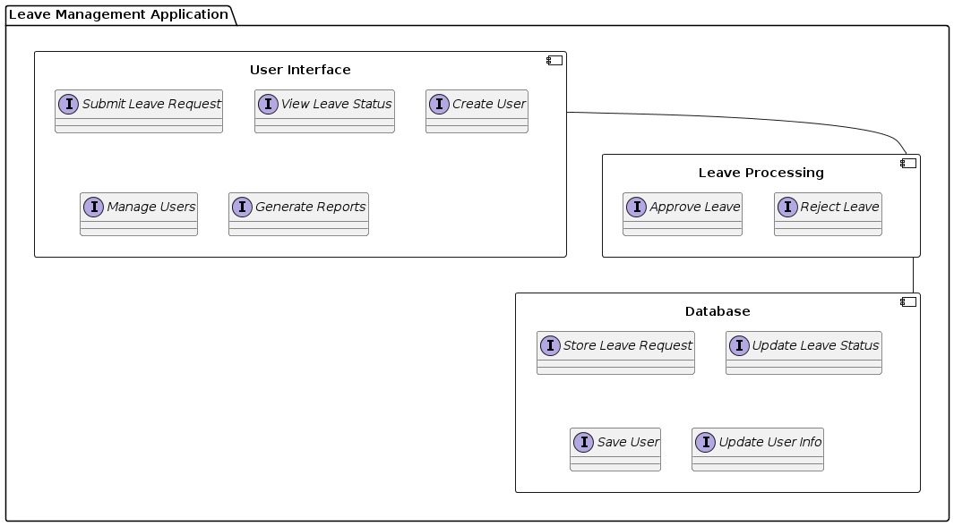

1. **Deployment Diagram**

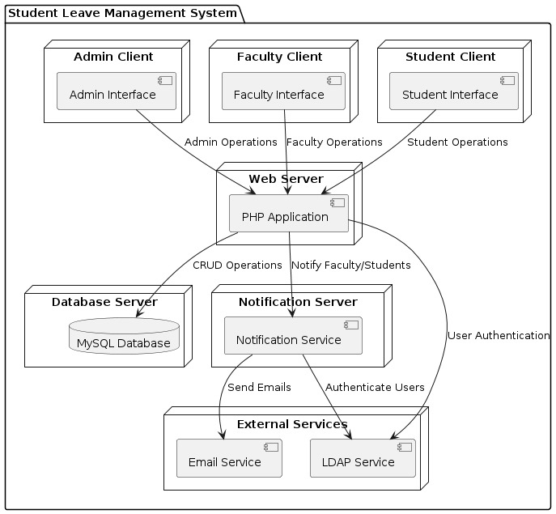

**7.MODULE DESCRIPTION:**

Each module serves a specific function within the system to manage leave requests, approvals, and related tasks efficiently:

### Authentication and Authorization Module

**Purpose**: Handles user authentication and access control.

**Functions**:

* + Login/logout functionality.
  + User role management (e.g., employee, manager, HR).
  + Security measures like password hashing and session management.

### Leave Request Workflow Module

**Purpose**: Orchestrates the flow of leave requests from submission to approval/rejection.

**Functions**:

Validate leave requests based on predefined business rules (e.g., notice periods).

### Reporting and Analytics Module

**Purpose:** Enables the generation of reports and analysis related to leave management.

**Functions:**

* Predefined report templates for leave balances, usage summaries, and compliance.
* Customizable reporting options with filters (e.g., by department, leave type).
* Visualization tools (e.g., charts, graphs) for data presentation and analysis.

**8.IMPLEMENTATION:**

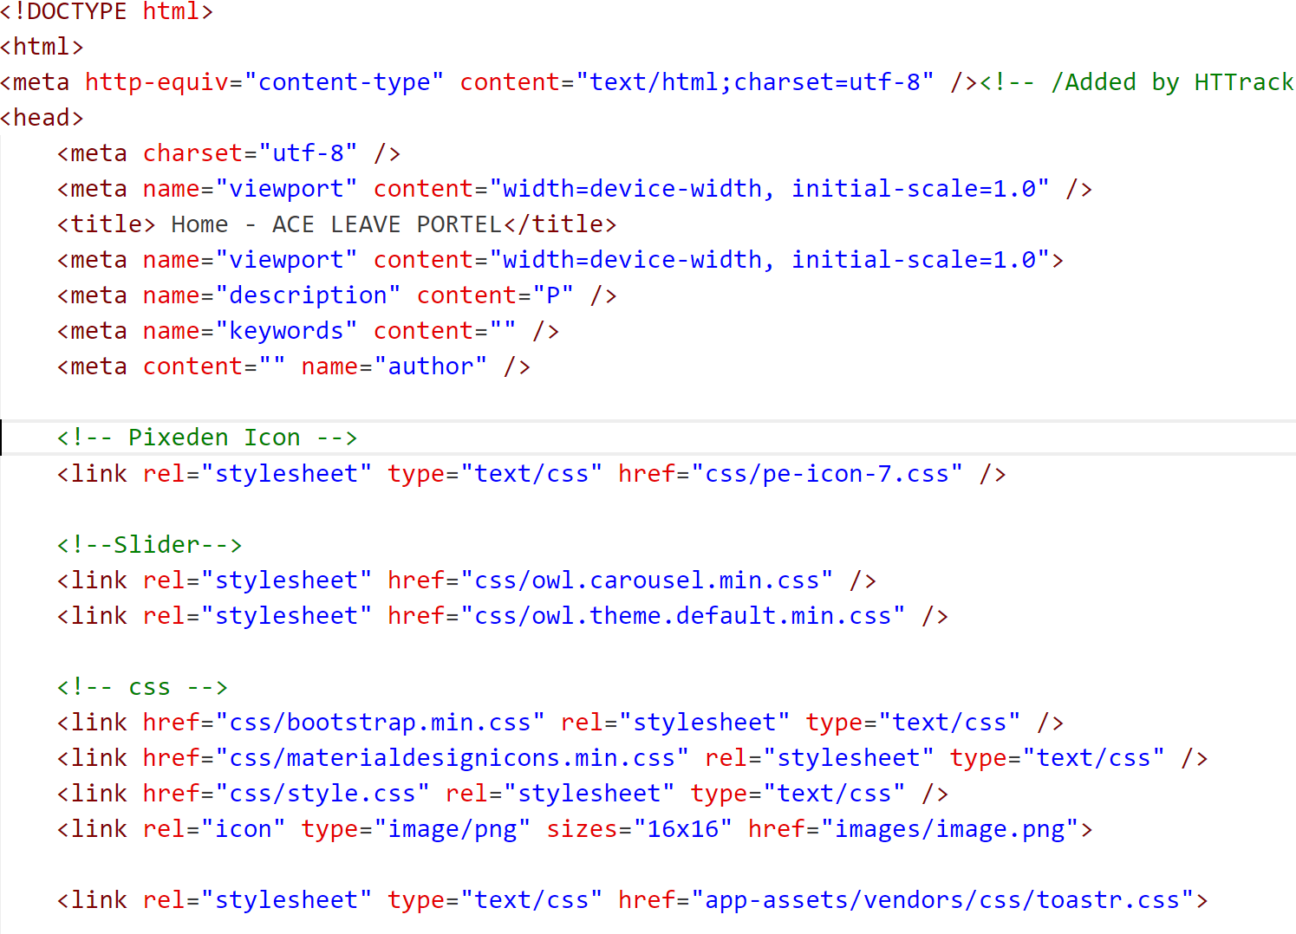

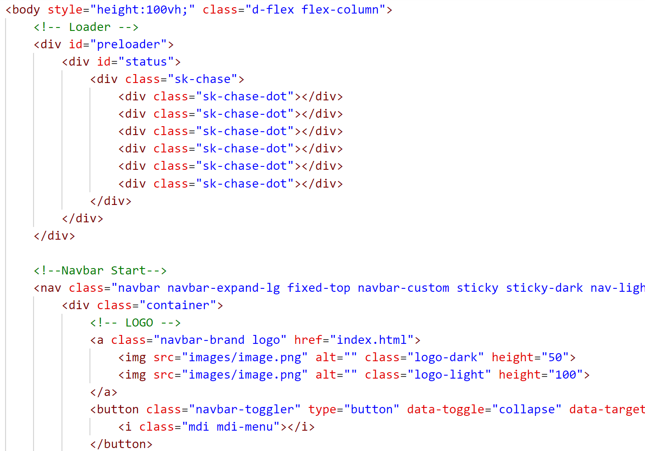

**9.TESTCASES:**

**Test Case 1: Valid Login**

* **Inputs**: Correct username and password.
* **Expected Outcome**: User should be logged in successfully and directed to the appropriate dashboard (employee, manager, or admin).

**Test Case 2: Invalid Login**

* **Inputs**: Incorrect username or password.
* **Expected Outcome**: User should not be logged in and should receive an error message indicating invalid credentials.

**Test Case 3: Access Control**

* **Inputs**: Attempt to access manager/admin features with an employee login.
* **Expected Outcome**: Access should be denied, and an appropriate message should be displayed indicating insufficient permissions.

**Test Case 4: Submit Leave Request**

* **Inputs**: Employee submits a leave request with valid details (leave type, dates, reason).
* **Expected Outcome**: Leave request should be successfully submitted and pending approval status should be displayed

**10.OUTPUT SCREENS:**

**Home Page:**

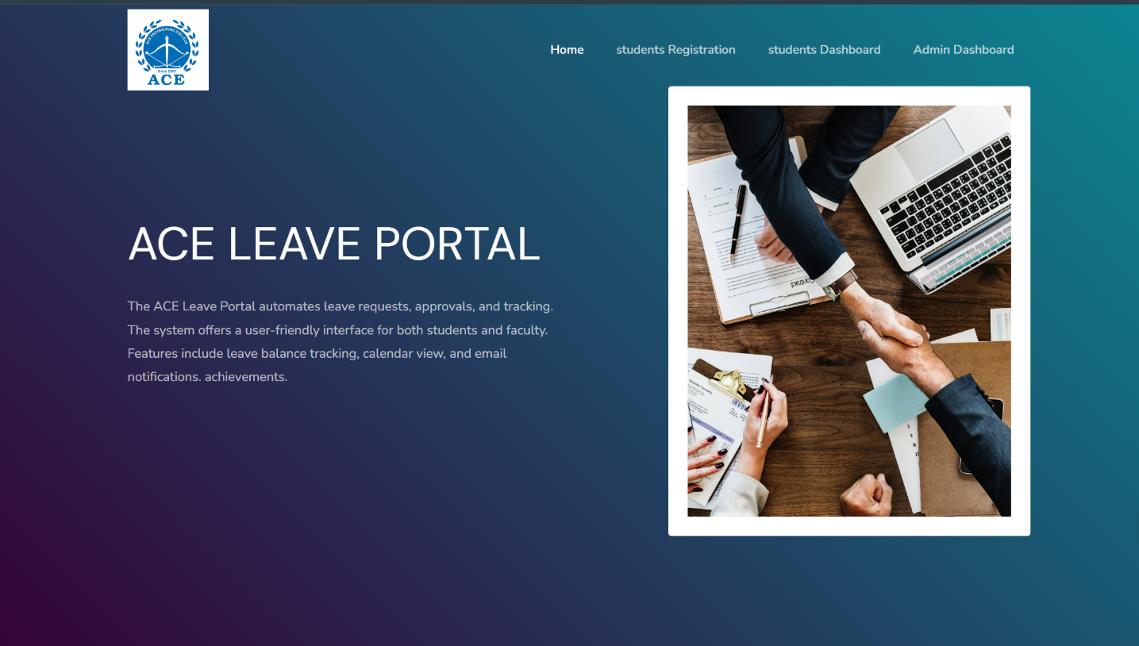

**STUDENT DASHBOARD:**

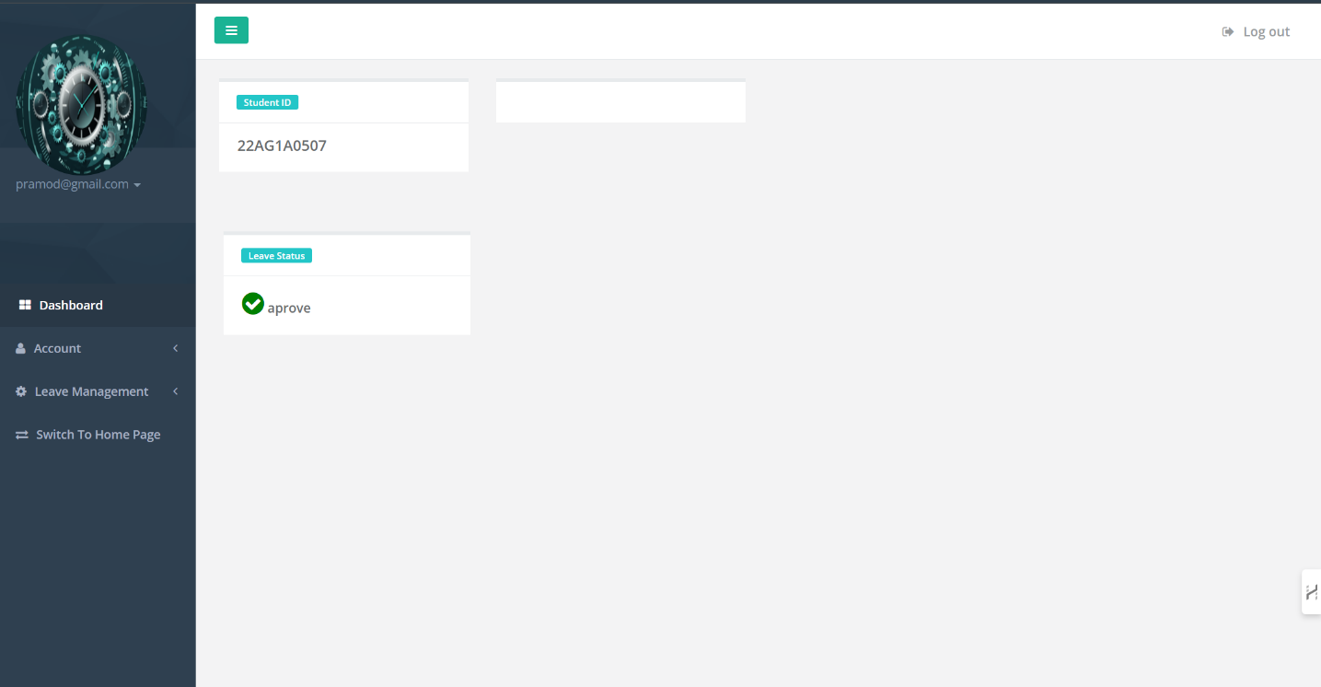

**STUDENT LEAVE APPLICATION:**

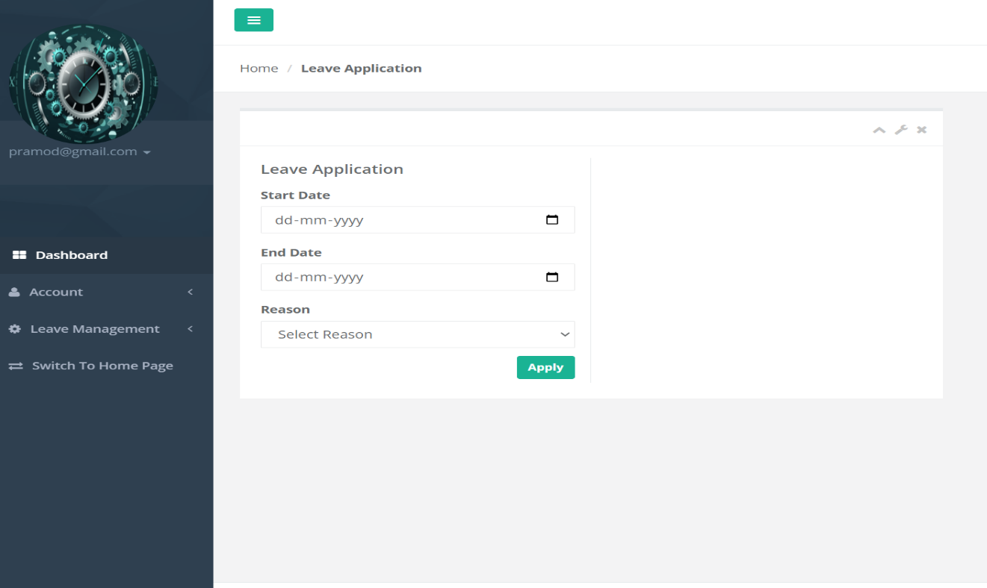

**LEAVE HISTORY:**

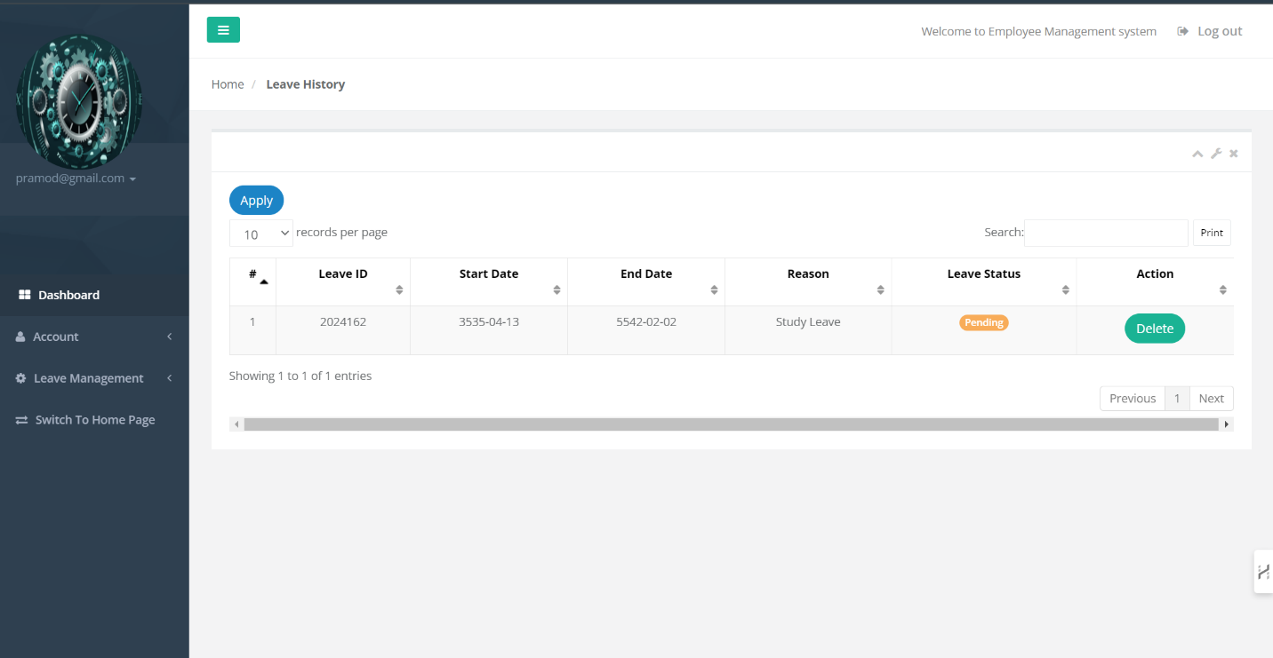

**ADMIN-DASHBOARD:**

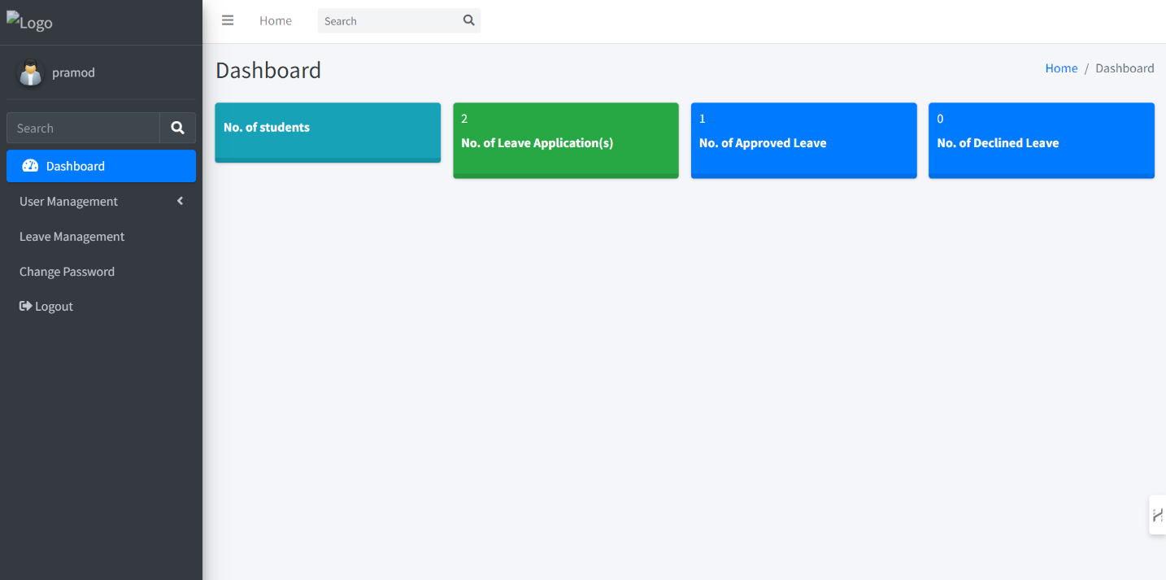

**CREATING-USER:**

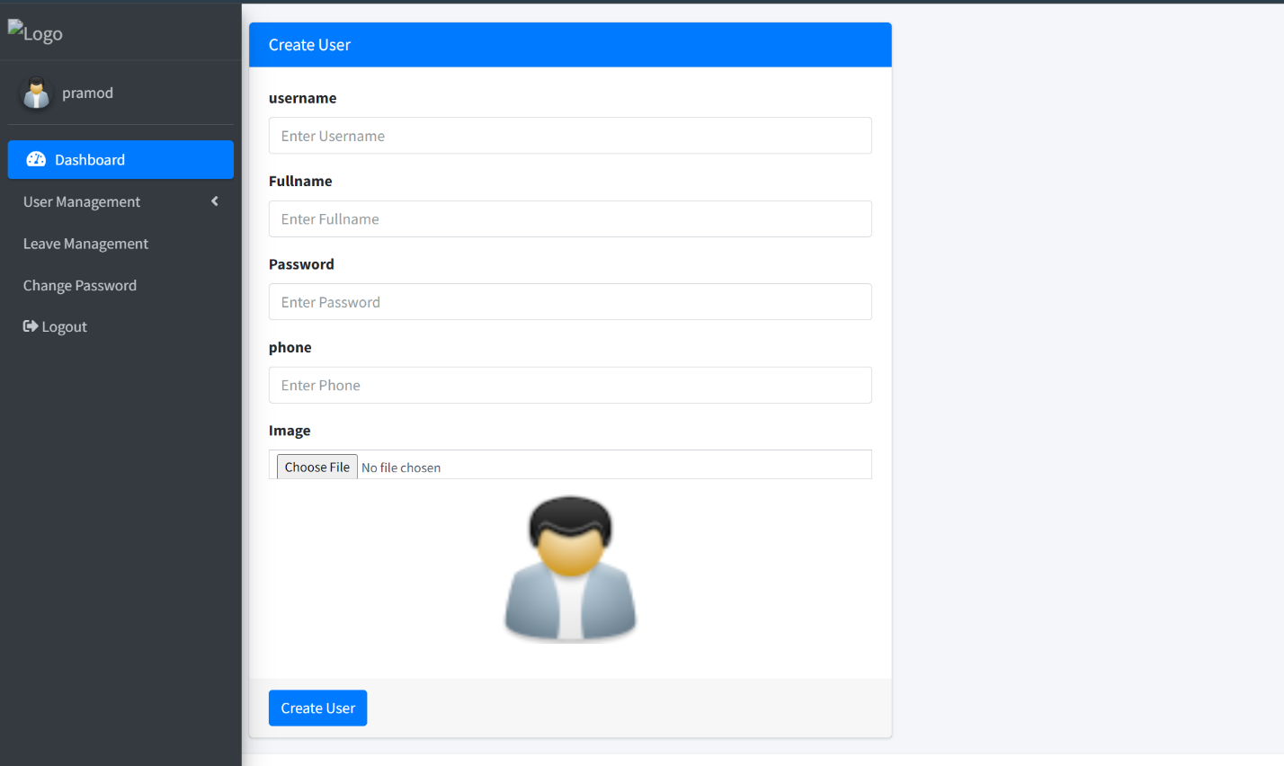

**LEAVE MANAGEMENT:**

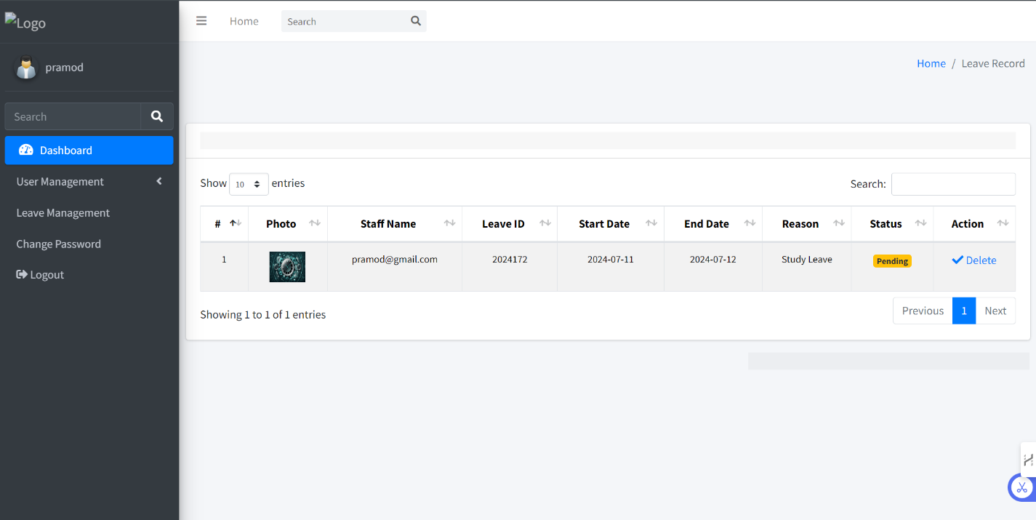

**11.CONCLUSION:**

the ACE Leave Portal System represents a significant step towards modernizing leave management in educational institutions. By addressing the challenges of traditional methods and embracing technological advancements, the system not only improves efficiency and accuracy but also enhances the overall experience for students, faculty, and administrators. As the system evolves with future enhancements, it will continue to contribute to the effective management and operational success of educational institutions.

**12.FUTURE ENHANCEMENTS:**

1 **Mobile Integration:**

* Developing a mobile application or responsive web design will allow users to access the system from their smartphones and tablets, increasing convenience and accessibility.

2 **AI and Machine Learning Integration:**

* Implementing AI algorithms to analyze leave patterns and predict future trends can aid in better resource planning and management. This could also help in identifying anomalies or potential issues proactively.

3 **Advanced Reporting and Analytics:**

* Adding more advanced and customizable reporting tools will provide deeper insights into leave data, helping administrators and faculty make more informed decisions.

**13.REFERENCES**

**Books and Journals:**

* Kothari, C. R. (2004). *Research Methodology: Methods and Techniques*. New Age International.
* Laudon, K. C., & Laudon, J. P. (2019). *Management Information Systems: Managing the Digital Firm*. Pearson.

**Articles and Papers:**

* Smith, J., & Brown, A. (2017). "Automating Leave Management Systems in Educational Institutions," *International Journal of Advanced Research in Computer Science and Software Engineering*, 7(3), 45-50.
* Lee, Y., & Cheng, C. (2018). "Improving Efficiency of Leave Management Using Web-Based Systems," *Journal of Information Systems Education*, 29(1), 12-18.

**Web Resources:**

* W3Schools. (n.d.). PHP Tutorial. Retrieved from https://www.w3schools.com/php/
* MySQL Documentation. (n.d.). Retrieved from <https://dev.mysql.com/doc/>

**Case Studies and Reports:**

* "Case Study: Implementation of an Automated Leave Management System in oxford University." (2020). Retrieved from <http://example.com/casestudy-oxford> university
* "Annual Report on Leave Management Systems in Higher Education." (2021). Retrieved from http://example.com/annualreport-2021